**Today, I have learned how to build and run Java code on a website using AWS Cloud.**

* For example, I have a Java code file in my GitHub repository (Nallendiran-JKM). Repository link for your reference: <https://github.com/Nallendiran-JKM/sample-java-spring-app.git>.
* In my GitHub repository, please select sample-java-spring-app.git.
* After that, you will see a **Fork** option.
* The **Fork** option is used to sync the repository files from my repository to your account's repository.
* After that please clone the **spring boot application** from Git Hub to our created **EC2 instance**.

We need only **pom.xml and src** file to run a code in a EC2 server.

If you open **src file,** the **java files** are there.

Pom.xml and src file was given by the developer.

We cannot run the file directly we need to compile. Below we can see how to compile and run the java file code.

1.We need to install maven tool - **Maven helps to build, manage, and organize Java projects efficiently.**

**sudo apt update**

**sudo apt install maven**

**After install the maven:** please use this command to check the **mvn --version**

**Now we start using compile**

**Next we can do mvn install-it will take 3 mins to download the dependencies.**

**After installation Build success was displayed in a screen.**

**Use ls command the one target was created and then open using cd command Now the**

**spring-boot-mongo-1.0.jar file was created. We cannot run jar file in Linux O/S. So that we need one**

**web-application called openjdk development kit. So use this command to install -sudo apt install openjdk-8-jdk**

**Once the file was installed Please check using this command java –version**

**Output displayed like this:**

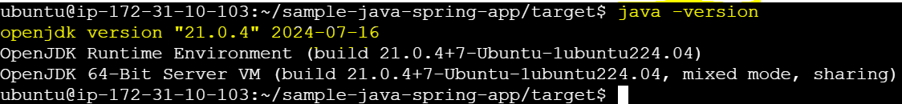

**The openjdk file and version was displayed in screen.**

**Now we can run and start the apllication –java -jar spring-boot-mongo-1.0.jar**

**Output displayed like this:**

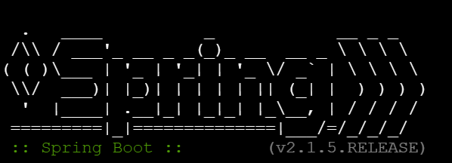

**Once this message was displayed in screen. The application is now started.**



**Now we can access the application in the internet.**

We can use our server's public IP address and port number to host in web.

If you want to host, the java web application. We need to allow 8080 port number in security group in our aws created instance.

After that Finally please enter the public ip address and port number in web

The hosting web pages like this:

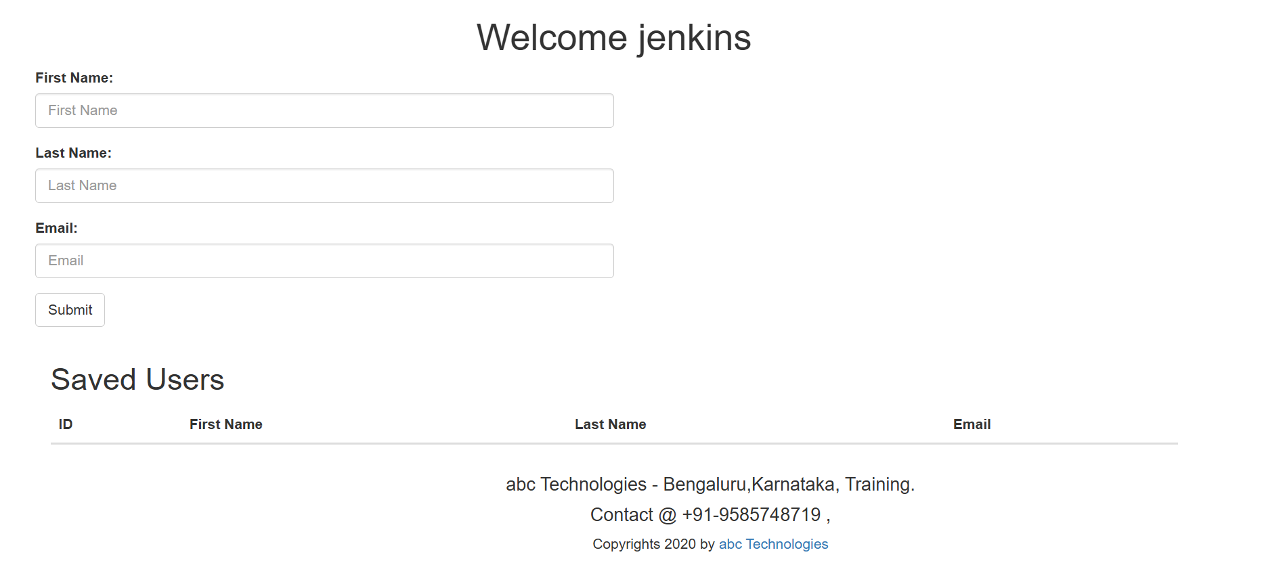

**The display came like this. The output is correct.**